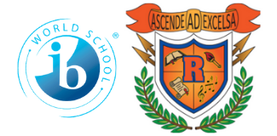

Ridgeway International Baccalaureate

Middle World Optional School

2022-2023

8th Grade School Supply List

Pencil Pouch **(No Pencil Boxes)**

Personal Pencil Sharpener

Loose Leaf Notebook Paper

No. 2 Pencils **(Wood or Mechanical)**

*\*If you purchase mechanical, please purchase lead also\**

Cap Erasers

Pens (red, black, and blue)

Ruler

Highlighters

Colored Markers

Glue Sticks

Colored Pencils

Crayons

Scissors

Kleenex **(Homeroom teachers will collect these)**

Dry Erase Markers (small tip)

Dry Erase Board

Lysol/Clorox Wipes **(homeroom teachers will collect these)**

Post-It Notes

Hand Sanitizer

USB Jump Drive

3-inch Binder

Sheet Protectors

8 count Dividers with tabs

Headphones (ear buds)

5 pocket folders with prongs

Index Cards

Graph Paper

Scientific Calculator (TI-30XS)

 – *for non-Algebra* *1 students*

Backpack (Preferably Clear or Mesh)

8 Composition Notebooks

Stylus (compatible with surface tablet)

Wireless Mouse (optional)